Predicate logic

We have to represent the knowledge. For this, we have some properties:

* **Representative suitability**: Ability to represent all types of knowledge required in that domain.
* **Inferential suitability**: Ability to manipulate the symbols of the representational formalism and infer a new desired knowledge.
* **Inferential efficiency**: Ability to incorporate meta-knowledge that allows to improve reasoning processes.
* **Purchasing efficiency**: The ability to easily acquire new knowledge from the outside, ideally under the control of the system itself while consistency with existing knowledge.

We have several types of knowledge:

* The ones that represent facts.
  + **Explicit**. Is entered directly.
  + **Implicit**. Inferred from explicit knowledge.
* **Procedural**. Indicates how to act through steps in various situations.
* **Meta-knowledge or control knowledge**. Knowledge at a higher level.

**What is logic?**

Logic is a formal language; it has a **syntax** that determines which expressions are legal. It also has **semantics** that determine what legal expressions represent. It usually has an **inference system**, that allows manipulating syntactic expressions to obtain other syntactic expressions.

There are 2 types of logic:

* Ontological commitment. Exists in the world.
* Epistemological commitment. Attitude towards the facts.



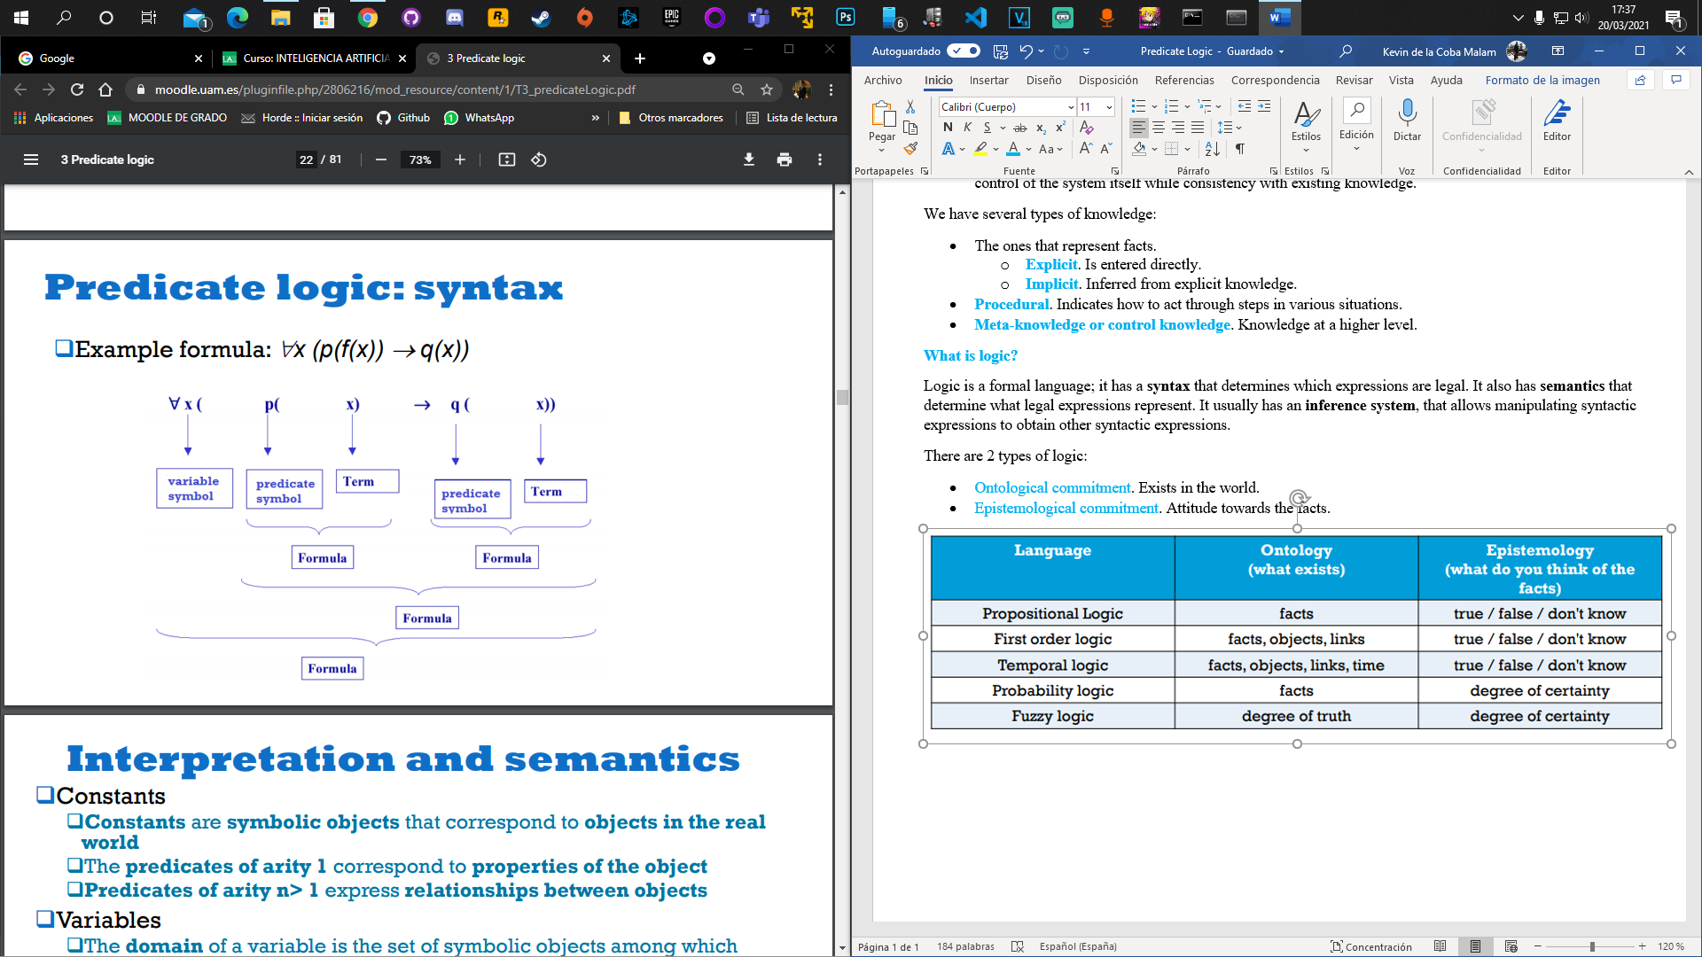

CNF in first order logic.

1. Eliminate implications.
2. Reduce the scope of $¬$.
3. Standardize variables. Rename variables so that each different variable in the set of wffs has a different symbol.
4. Skolemization. Eliminate existential quantifiers and replace existentially quantized variables by skolem constants or skolem functions as appropriative.
5. Convert to prenex from by moving all universal quantifiers to the beginning of the wff.
6. Drop universal quantifiers.
7. Use distributive laws and equivalence rules of propositional logic to transform the matrix to CNF.